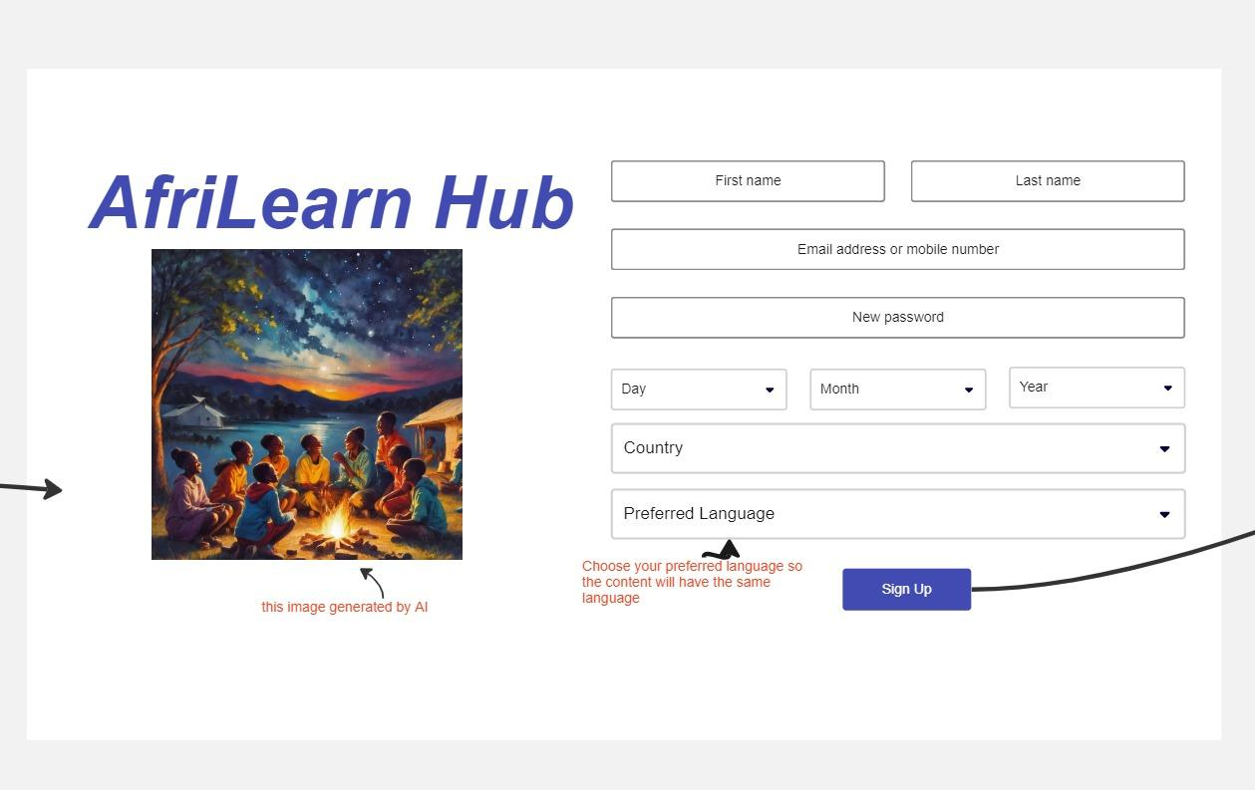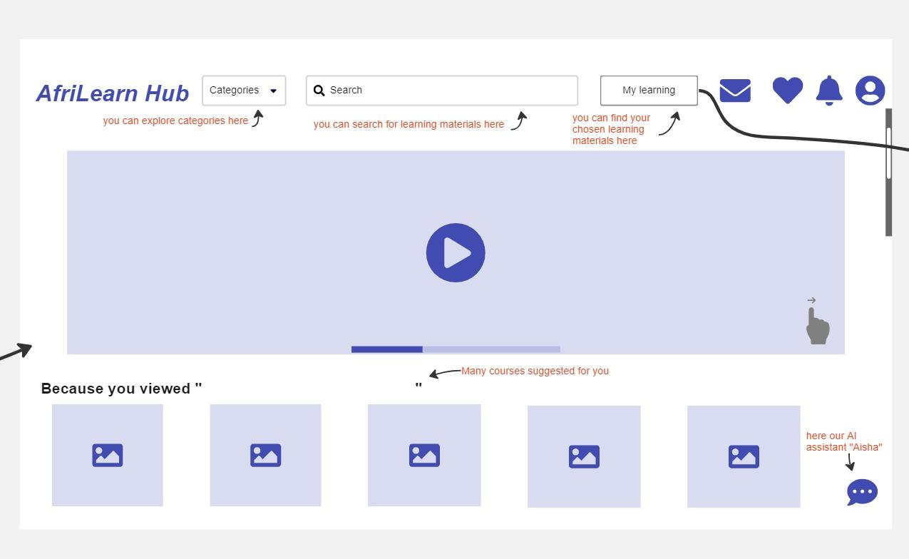

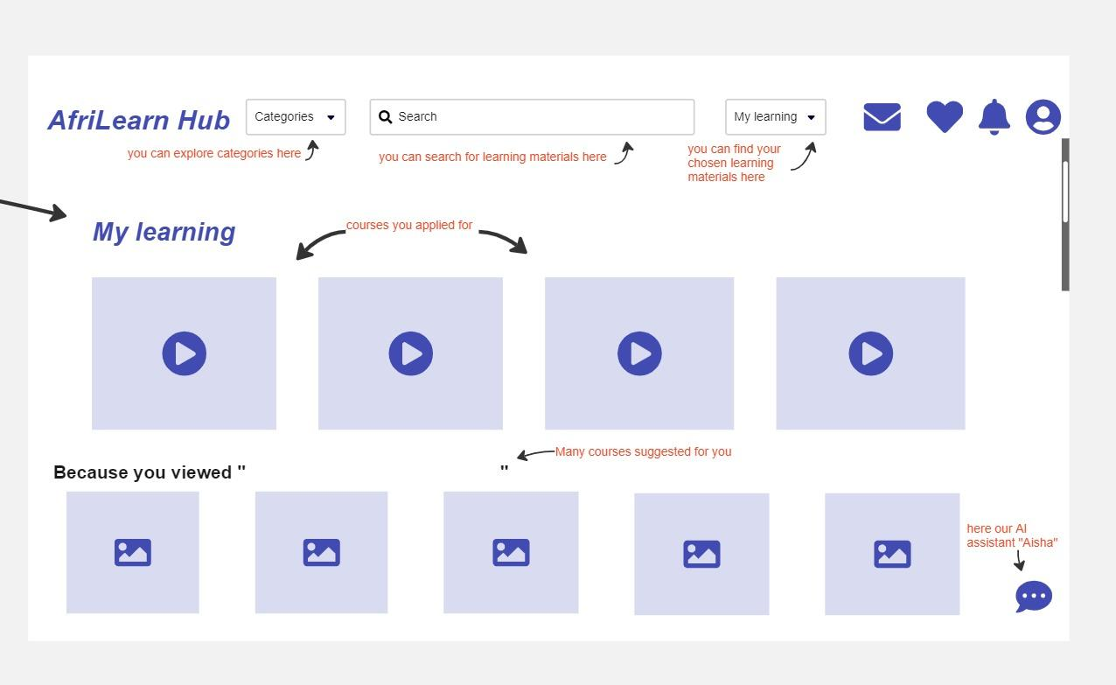

**2. The overview of the team’s process and the challenging thing of creating the wireframes:**

* Throughout the experience, we have learned the importance of iterative design to refine the wireframes based on feedback and insights gained throughout the process.
* The most challenging aspects of this process is often striking the right balance between simplicity and detail. It is crucial to convey the core functionalities without overwhelming the user with too much information.

**3. Link to the Pitch Slide Deck**

<https://drive.google.com/file/d/1gGtlEgCBTXO3N7m9trU1bNY5MxKhMXbz/view?usp=sharing>

**3. Please briefly describe your role in helping create the slide deck.**

**4. Please answer the following questions.**

**A. What is working well with your team?**

**B. What is one good thing that happened during your team meeting?**

**C. What is one thing your team could do better in the next meeting?**

**D. Are you experiencing any concerns or frustrations with your team? If yes, what can you personally do to lessen the concern/frustration?**

**E. How would you rate your ability to communicate with your team members on a scale of 1**

**to 4? (1=extremely poor and 4=excellent)**

**F. Overall, how satisfied are you with how well your team is working together? (On a scale of 1 to 4, with 1=extremely poor and 4=excellent)**

**G. Is there anything else you’d like to share about your team and their process?**